DAY 4
Open database
https://www.exploit-db.com/google-hacking-database?category=9
https://nvd.nist.gov/

Cloud Linux Environment
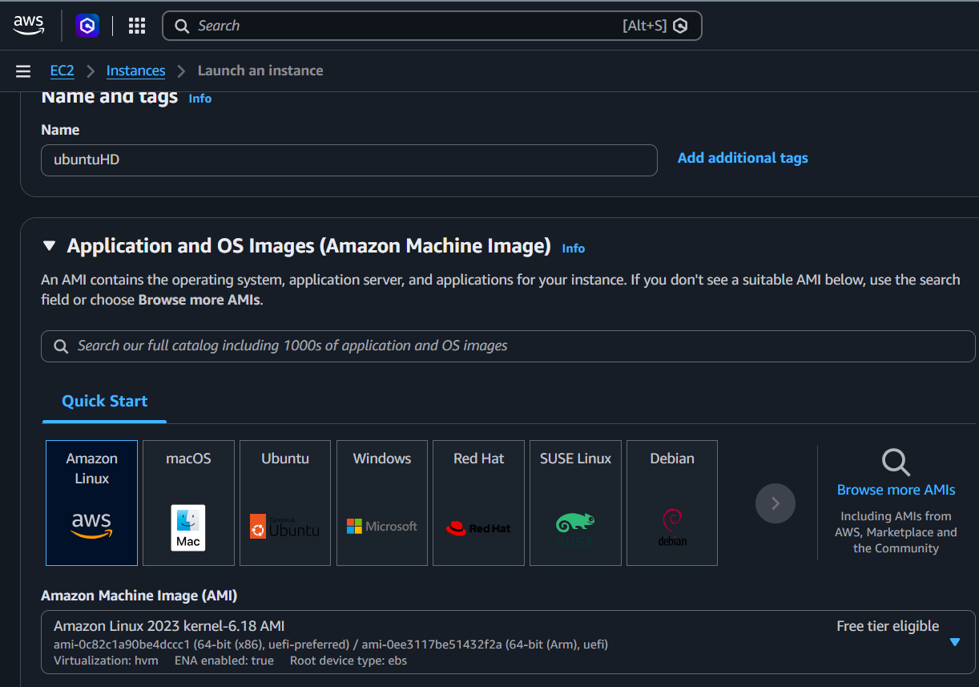

Command :
- Open file
- python3 -m venv .venv
- source .venv/bin/activate
- user-scanner -u “USERNAME”
- user-scanner -e “EMAIL”
- 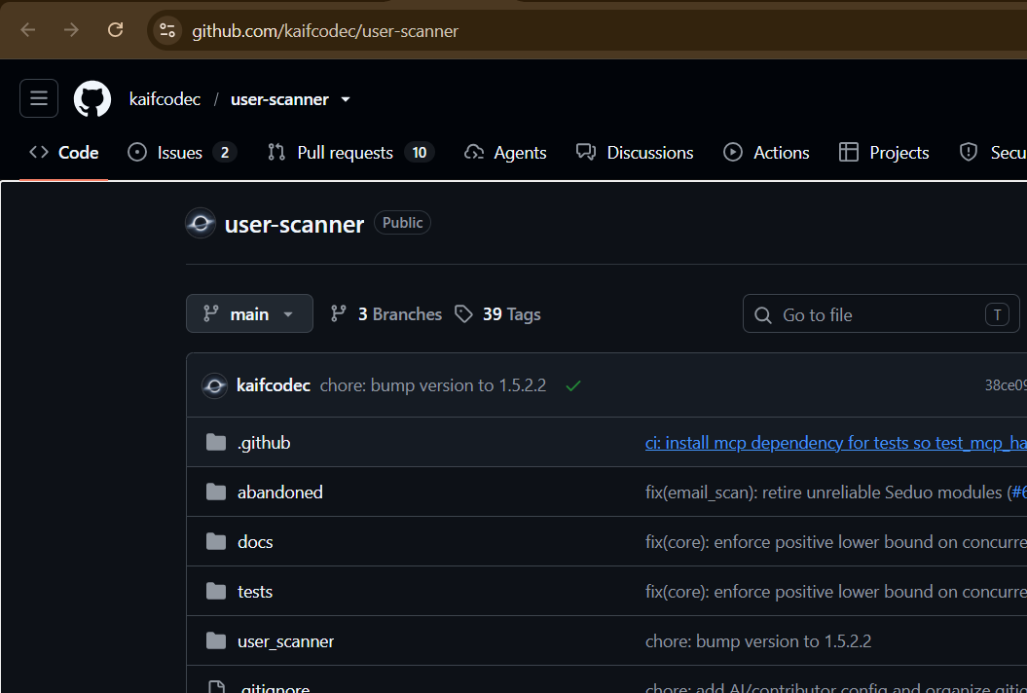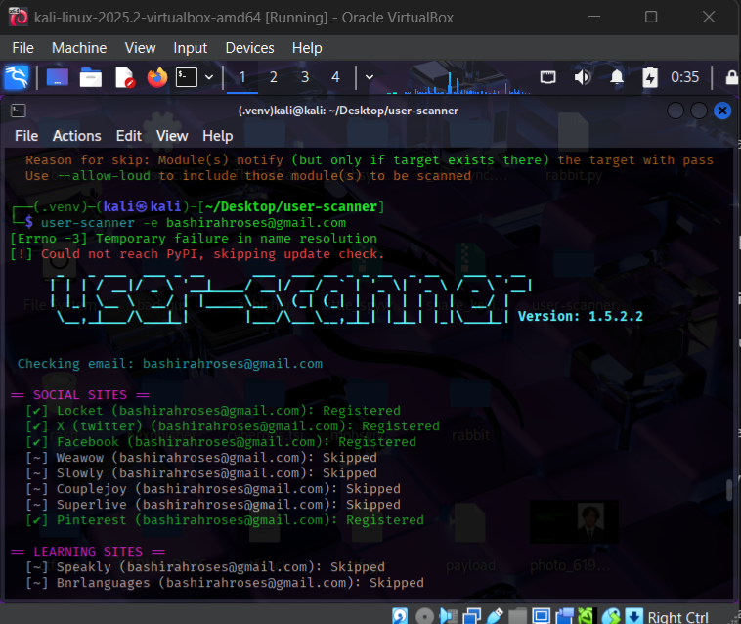

Command :
- Open files
- python3 -m venv .venv
- source .venv/bin/activate
- sherlock “USERNAME”

